Grapheme–color synesthesia

🧠🎨 What is Grapheme–Color Synesthesia?
# Source: Chatgpt (GPT-4-turbo) at [7/24/2025]
Grapheme–color synesthesia is a neurological condition where a person automatically and involuntarily associates colors with letters or numbers (called graphemes). For example, someone might always see the letter A as red, B as blue, or the number 7 as green—even if it’s printed in black ink.

📘 Definition:
# Source: Chatgpt (GPT-4-turbo) at [7/24/2025]
Grapheme–color synesthesia is a type of synesthesia in which letters and numbers evoke the perception of specific colors, even though those graphemes aren’t colored.

🧠 How It Works:
# Source: Chatgpt (GPT-4-turbo) at [7/24/2025]
- It involves cross-activation in the brain between:
  - The area for recognizing symbols (graphemes)
  - The color-processing region (called V4)
- The association is automatic, consistent, and often lifelong

Grapheme–color synesthesia Photo
# Source: Wiki source: Grapheme–color synesthesia -> at - (Top)
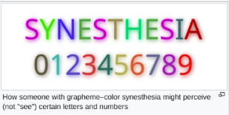

🧒 Example Experiences:
# Source: Chatgpt (GPT-4-turbo) at [7/24/2025]

Grapheme | Synesthetic Color
A | Red
B | Blue
C | Yellow
1 | White
2 | Green
3 | Orange
Even if all letters are written in black, the synesthete “sees” them in these colors in their mind.

🔍 Key Characteristics:
# Source: Chatgpt (GPT-4-turbo) at [7/24/2025]
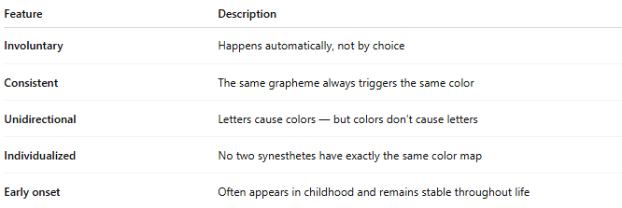
Feature | Description
Involuntary | Happens automatically, not by choice
Consistent | The same grapheme always triggers the same color
Unidirectional | Letters cause colors — but colors don’t cause letters
Individualized | No two synesthetes have exactly the same color map
Early onset | Often appears in childhood and remains stable throughout life

🧬 Is It Common?
# Source: Chatgpt (GPT-4-turbo) at [7/24/2025]
- It’s one of the most common types of synesthesia.
- Some estimates suggest 1 in 200 to 1 in 5,000 people experience it.
- More common in creative individuals, and it may run in families.

✅ Summary:
# Source: Chatgpt (GPT-4-turbo) at [7/24/2025]
Grapheme–color synesthesia is when a person automatically sees or feels colors associated with letters and numbers.
It’s consistent, involuntary, and happens inside the mind, even if the symbols are printed in black.

